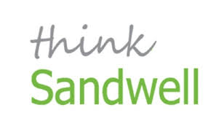
Thank you for your interest in #madeinsandwell Monday.
We aim to publish a profile of a different Sandwell business every Monday, giving readers an engaging overview of what our featured business makes and where its products are used.
#madeinsandwell Monday is a celebration of the talent and diversity of businesses in our borough.
Each profile is shared through Twitter and with other local organisations, so taking part would be a great way to promote your business. It costs nothing except a few minutes of your time.
For a chance to be profiled, please complete the following questions. Then email this completed document to us at the address at the bottom, attaching one or two good-quality images and, if possible, your company logo.
You may receive a quick call from our copywriter so we can expand on, or clarify, some of your answers.
We look forward to hearing about your #madeinsandwell marvels . . .
Name of business:

Address:
Your name and job title:

Direct contact number:

Email address:

Please summarise what it is your company does, and makes.
If you have a comprehensive ‘about us’ page on your website, feel free to refer us to it:

Please give us more information about the history of your business.
How did you come to be making the products you do?
Are you a long-established organisation or relatively new?
Is it a family firm?
Have you relocated to Sandwell from elsewhere (and, if so, what attracted you to the borough)?
Tell us about your workforce – how do they make your company the unique entity it is today?
And how does being in Sandwell benefit your organisation?
What makes you most proud about your business?
What are your company’s plans for the future?
Is there anything else you’d like to tell us about? For example – has your business won an award lately? Have your products been recommended by someone famous, or used somewhere high profile? Have you taken on new staff or launched a new initiative?
Please email this completed document to think_sandwell@sandwell.gov.uk, along with one or two high-quality images and, if possible, your company logo. We will contact you if we are able to profile your business. We will have the final editorial decision but you are welcome to see and approve a drafted version before publication.

